Traffic Signals

**Will a traffic signal help reduce accidents? How does the Town decide where to install traffic signals?**   
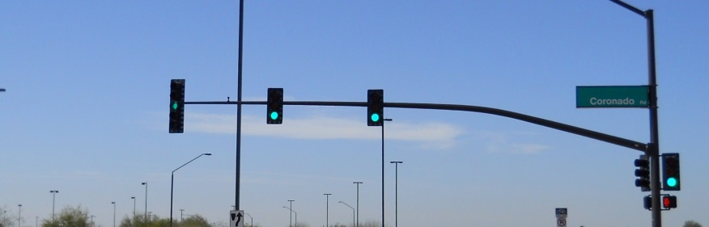 **Signals don't always prevent crashes**  
The Town of Gilbert's Traffic Engineering Department wants to ensure that when a traffic signal is installed at a specific location, traffic and pedestrian safety are improved. Traffic signals do not always reduce the total number of crashes at an intersection, but the types and severity of crashes may change.

.

**When is a signal installed?**  
  
Traffic signals are a tremendous investment for the Town. Design and installation costs exceed $300,000 for every signal installed (plus monthly power and maintenance costs). Therefore, the Town carefully prioritizes where and when traffic signals will be installed.  
  
When determining whether or not a traffic signal is necessary at a specific location, the Gilbert Traffic Engineering Department evaluates and tries to answer several questions:

* How much traffic is on the main streets and minor streets,
* Are high levels of traffic consistent throughout the day or just during a short period?
* Are there many pedestrians?
* Is the street a wide, high speed, and busy thoroughfare?
* Are school children crossing the street?
* Will a signal improve the flow of traffic or cause congestion with other nearby signals?
* Is there a pattern of crash types that are correctable with a signal?

**National Standards**

The Town of Gilbert collects all of traffic volume and crash data at a location that is being considered for a traffic signal. Once the data are collected, they are compared to standards that have been established by extensive research and experience. These standards, called "[Traffic Signal Warrants](http://mutcd.fhwa.dot.gov/)" are used by traffic engineers throughout the United States to help determine appropriate signal locations. The Town of Gilbert conducts Traffic Signal Warrant Analysis annually at 10 to 20 intersections.  
  
A properly placed signal can improve the flow of traffic and decrease accidents. An unnecessary one can be the source of danger and annoyance to all who use the intersection including pedestrians, bicyclists, and motorists.  
  
**Drawbacks to a signal**  
  
Signals cause unnecessary delays to drivers during certain times of the day. This increase in delay increases air pollution. It can also cause driver frustration if there is not much traffic on the major street.

If you would like an intersection considered for a traffic signal please call 480-503-6186.

Children at Play Signs

**When are warning signs used?**

Warning signs are most effective when used sparingly and are intended to advise motorists of an unusual or unexpected condition ahead. These signs have little value as they become overused.

National studies have shown that many signs which warn of normal conditions in residential areas fail to improve safety. Since children live on just about every single block in the Gilbert, there would have to be signs on every single street in Gilbert. Blocks without signs might imply that no children live there, so it is okay to speed.

**Not an official sign**

The Town of Gilbert must comply with state and federal laws when it comes to traffic control devices. The "Children at Play" sign is not a recognized sign by the national "Manual on Uniform Traffic Control Devices." The primary reason that the sign is not approved for use is that research has proven that the sign does not reduce pedestrian accidents or lower vehicle speeds.

**Promoting a false sense of security**

Some neighborhood traffic control signs, designed with the intent to provide security and safety for the families who live there, can often have the exact opposite results. The "Children at Play" sign is perhaps the best example.

Residents may have the wrong impression that somehow with the sign it is safer to play in the street. The signs may also encourage parents to believe that there is some added protection in the neighborhood.

This is simply not the case. Children should be taught that the street is not a place to play. It is intended for cars and bicycles. Further, children must be taught that not all drivers are watching out for children.

**For more information...**

The Town of Gilbert Traffic Engineering Department wants to work with you to ensure your safety. For additional driving and safety tips, please call 503- 6186.

Walk/Don't Walk Indications

To this day, the Walk/Don't Walk lights at a signalized intersection are one of the most commonly misunderstood traffic control devices.

[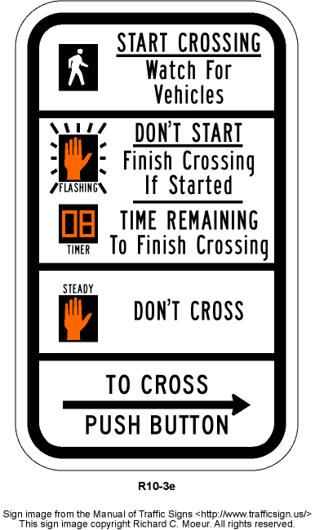](http://www.google.com/url?sa=i&rct=j&q=&esrc=s&frm=1&source=images&cd=&cad=rja&uact=8&ved=0CAcQjRw&url=http://www.trafficsign.us/r10.html&ei=JufbVKeMJ8SzogSIn4HgCQ&bvm=bv.85761416,d.cGU&psig=AFQjCNG3ILD61xBMSzQkJBmltQXVoU7FRQ&ust=1423783866962599)

**"WALK"**

The WALK symbol is indicated by either the word WALK or the symbol of a person walking. In both cases, the color of the indication is white. The WALK indication is typically on for 4 - 8 seconds. When the WALK is illuminated, it is okay for a person to enter the street or begin crossing.

**Flashing "DON'T WALK"**

The flashing DON'T WALK indication is an orange flashing symbol of a hand, and will provide a countdown timer until the indication changes to “Don’t Walk.

After the 4 - 8 seconds of WALK time, the signal will begin to flash DON'T WALK. Most pedestrians will not have made it all the way across the street by this time. THIS IS HOW THE SIGNAL IS SUPPOSED TO FUNCTION. If you are already crossing the street, you will have plenty of time to make it to the other side. If you have not begun to cross, DO NOT step off the curb.

**"DON'T WALK"**

When the DON'T WALK signal is on and not flashing, DO NOT step into the street or begin crossing. **Push the Button**  
  
 WALK indications do not activate during every cycle of the traffic signal In order to bring up the WALK indication, you must push the pedestrian button located on the traffic signal pole. By using this button, you will have enough time to cross the street once the WALK signal appears.

Speed Limit Signs  
  
Will a lower speed limit slow traffic down?  
  
It is a common myth that posting slower speed limit signs forces drivers to slow down and will result in fewer traffic accidents. National research has shown that drivers are influenced by the prevailing traffic conditions and the type of street, not the posted speed limit.  
  
**The Law in Arizona**  
  
From Arizona Revised Statutes 28-701 'A person shall not drive a vehicle on a highway at a speed greater than is reasonable and prudent under the circumstances, conditions and actual and potential hazards then existing. A person shall control the speed of a vehicle as necessary to avoid colliding with any object, person, vehicle or other conveyance on, entering or adjacent to the highway in compliance with legal requirements and the duty of all persons to exercise reasonable care for the protection of others.'  
  
Except as provided elsewhere in the statute or except if a special hazard requires a lesser speed, any speed in excess of the following speeds is prima facie evidence that the speed is too great and therefore unreasonable:   
  
1. Fifteen miles per hour approaching a school crossing  
  
2. Twenty-five miles per hour in a business or residential district unless otherwise posted

**Gilbert's policy on speed limit signs**  
  
Speed limit signs are typically installed at quarter-mile intervals on the major arterial streets such as Cooper Road, Elliot Road, and Val Vista Drive.  
  
Signs are also posted at half-mile intervals on collector streets such as Houston Avenue, Burk Street, and Neely Street.  
  
Finally, 25 mph speed limit signs are installed at the entrances to subdivisions where the speed limit changes from a higher limit (30, 35 or 45 mph) to the residential speed limit (25 mph). It is not practical to install speed limit signs at the end of every residential street in the Town of Gilbert.  
  
**Studies help set speed limits**  
  
If an unreasonably low speed limit is posted; many drivers tend to ignore the signs. There are some drivers who, on the other hand, always try to stay within the posted speed limit. This can cause conflict between faster and slower drivers, resulting in more accidents.

Traffic engineering studies help to determine the prevailing speed of most drivers using a certain street. Additionally, the studies take into account accident records and road conditions. An appropriate speed limit is then set based upon this data.

Stop Signs   
  
Under the right conditions, STOP signs can play an important role in traffic safety, by assigning right of way to vehicles at intersections  
  
**Will more stop signs slow traffic on my street?**  
Many requests are received for STOP signs to interrupt traffic or slow traffic down. However, studies in Arizona and across the nation show that there are a high number of intentional violations when STOP signs are installed as nuisances or speed breakers.

Under the right conditions, STOP signs can play an important role in traffic safety. However, STOP signs installed in the wrong place usually create more problems than they solve.

Stop signs are installed at an intersection only after a careful engineering evaluation of the existing conditions indicates that their installation is appropriate.  
  
  
Four-way STOPS are only helpful when traffic volumes are high and close to equal on all approaches to an intersection.  
  
**What is the law regarding who has the right of way?**  
  
When two vehicles enter an intersection from different streets at the same time, the driver on the left shall yield right-of-way to the driver on the right. The only exception is at a "T" (or 3-leg) intersection where the driver on the through street has the right-of-way.  
  
**Will the Town look into my concerns about stop signs?**  
The Town receives many requests every year to install STOP signs. The Town uses its engineering standards and the national standards to determine whether a STOP sign is a useful and reasonable traffic control device for that location. The Town will not install stop sign to “slow” traffic on streets.  
  
Low volume streets within neighborhoods tend to operate best under the state right-of-way law. This law requires drivers to approach an intersection cautiously and to control their speed to a reasonable level.